Application Form – High Voltage Type

Please refer to our website glossary for all terms and additional feature definitions

CUSTOMER DETAILS: | Date:
Customer: | Contact Name:
Enquiry Origin (Country): | Telephone:
Address:
 | Email:
 | Web Site:
Type of Business: Manufacturer (OEM): Distributor: Individual (Private Use):

SPECIFY APPLICATION TYPE:
Projected Annual Quantity:
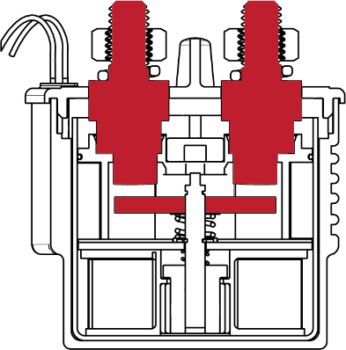
MAIN CONTACT CONFIGURATION:
Normally Open (N.O.):

MAIN CONTACT LOADS:

 | Ie Current (A): | Duration (Minutes): | Ue Voltage (V): | Duration (Minutes):
Nominal

Minimum

Maximum

TYPE OF LOAD: | Contacts Closing on Load: Yes: No:
Resistive: | Contacts Opening on Load: Yes: No:
Inductive: | Approximate Closing Load (A):
Capacitive: | Approximate Opening Load (A):
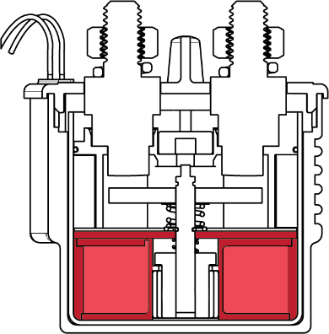
COIL RATING: | Us Voltage (V): | Duty Cycle | Duration (Minutes): | Ambient Temperature (Deg C.)
Nominal

Minimum

Maximum

Maximum Inrush Current
Note: Intermittent (INT) coils must be used in conjunction with Customers own PWM circuit. For other short duty application requirements (such as pump control circuits), please contact Albright Technical.

COIL OPERATION:

PWM: | Magnetic Latching:
Intermittent (INT):

Frequency of Switching: | No of Cycles: |  |  | per Seconds / Minutes / Hours / Days
Duty Cycle: |  |  | On Time in Seconds / Minutes / Hours / Days
 |  |  | Off Time in Seconds / Minutes / Hours / Days
 |  | Please indicate unit of measure by circling appropriate value

Environmental Considerations
(e.g. humidity, moisture):

Albright International Ltd, Evingar Trading Estate, Ardglen Road, Whitchurch, Hampshire, RG28 7BB, UK,
Tel: +44 (0)1256 893060, Fax: +44 (0)1256 893562, Dedicated Sales Tel: +44 (0)1256 890030, Fax: +44 (0)1256 890043,
E-mail: sales@albrightinternational.com or technical@albrightinternational.com Web Site: www.albrightinternational.com

v1-05-21 Copyright © 2021 Albright International LTD

Application Form – High Voltage Type

ADDITIONAL FEATURES:
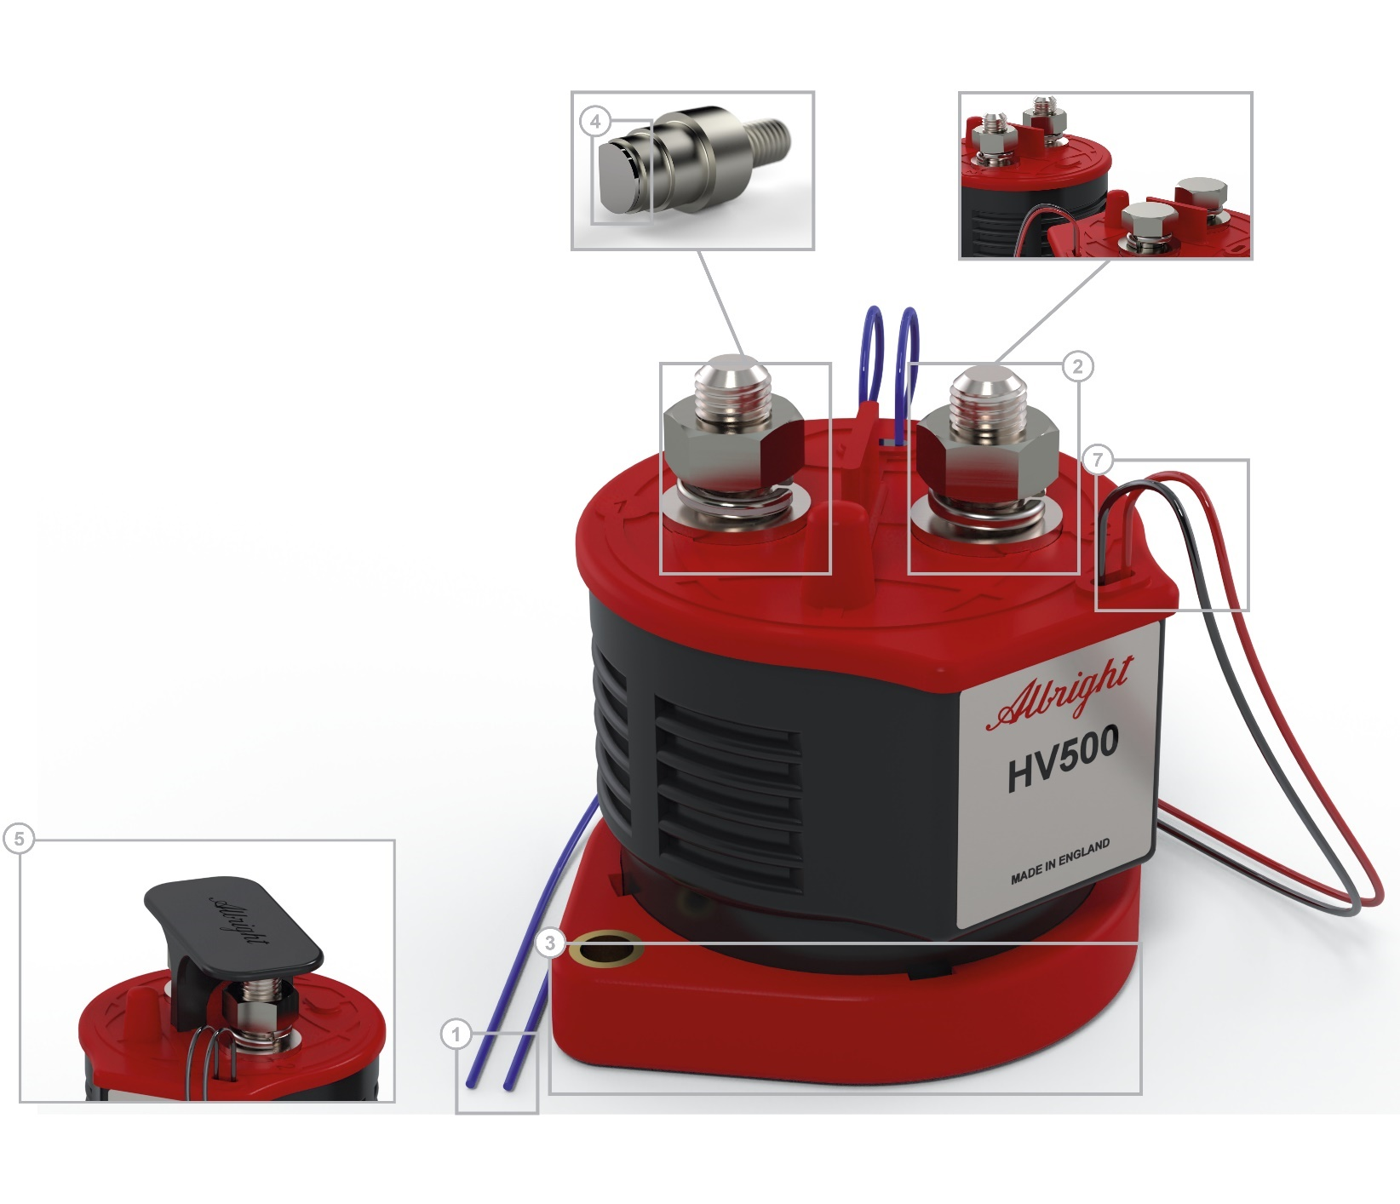
Feature: | Select as  Appropriate: | Suffix:

1. | Auxiliary Contacts:
 | NO |  | A
 | NC |  | A
 | NC Mirror |  | A
2. | Main Contacts:
 | M6 Female
 | M8 Female
 | M8 Male (fitted as standard)
 | M10 Male
3. | Bracket  If bracket is required, please select fitment option from the Fitted Bracket Angle section
4. | Silver Contacts |  | S
5. | Terminal Guard
6. | Magnetic Latching |  | M
7. | Flying Leads (fitted as standard) |  | F

Fitted Bracket Angle

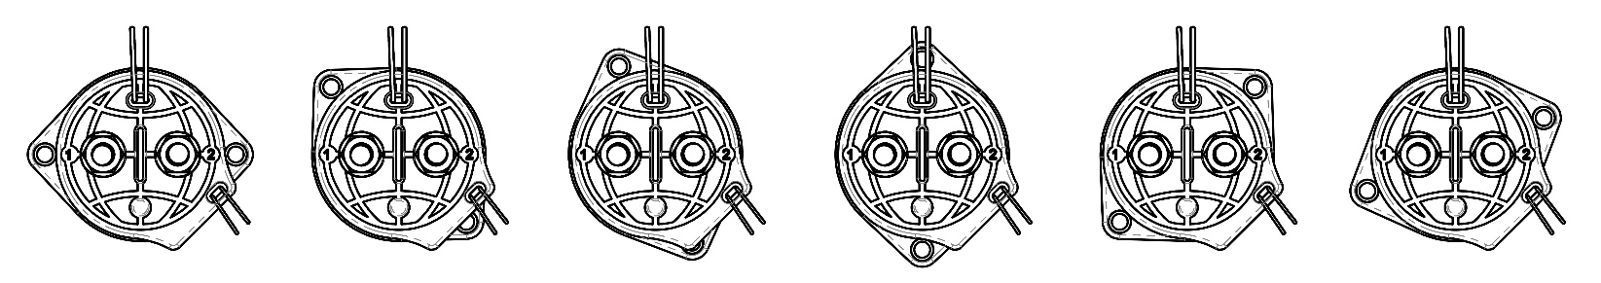  Angle 0° | Angle 45° | Angle 67.5° | Angle 90° | Angle 135° | Angle 157.5°

NOTES:

Albright International Ltd, Evingar Trading Estate, Ardglen Road, Whitchurch, Hampshire, RG28 7BB, UK,
Tel: +44 (0)1256 893060, Fax: +44 (0)1256 893562, Dedicated Sales Tel: +44 (0)1256 890030, Fax: +44 (0)1256 890043,
E-mail: sales@albrightinternational.com or technical@albrightinternational.com Web Site: www.albrightinternational.com

v1-05-21 Copyright © 2021 Albright International LTD

