Application Form

Please refer to our website glossary for all terms and additional feature definitions

CUSTOMER DETAILS: | Date:
Customer: | Contact Name:
Enquiry Origin (Country): | Telephone:
Address:
 | Email:
 | Web Site:
Type of Business: Manufacturer (OEM): Distributor: Individual (Private Use):

SPECIFY APPLICATION TYPE:
Projected Annual Quantity:
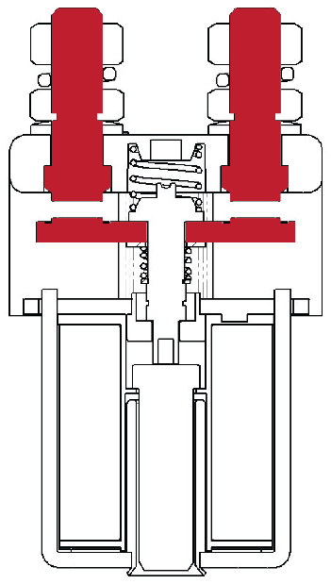
MAIN CONTACT CONFIGURATION (COMPLETE THE APPROPRIATE BOXES):
Single Pole (1P) | Double Pole (2P) | Changeover
Normally Open (N.O.) | Normally Closed (N.C.) | Motor Reverse
Other (Explain):

State Contactor Type number (if known):

MAIN CONTACT LOADS:

 | Ie Current (A): | Duration (Minutes): | Ue Voltage (V): | Duration (Minutes):
Nominal

Minimum

Maximum

TYPE OF LOAD: | Contacts Closing on Load:
Resistive: | Contacts Opening on Load:
Inductive: | Closing on Maximum Load:
Capacitive: | Opening on Maximum Load:
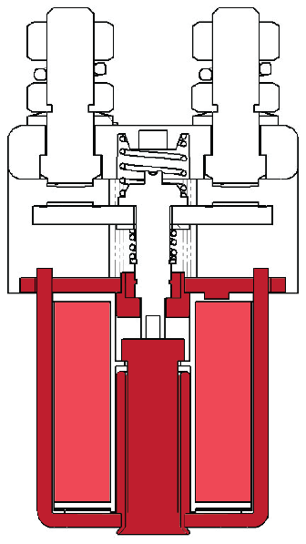
COIL RATING: | Us Voltage (V): | Duration (Minutes): | Ambient Temperature (Deg C.)
Nominal

Minimum

Maximum

Maximum Inrush Current

COIL OPERATION:

Continuous (CO) [100% Duty]: | Prolonged (PO) [90% Duty]:
Intermittent (INT) [70% Duty]: | High Powered (HO) [25% Duty]:
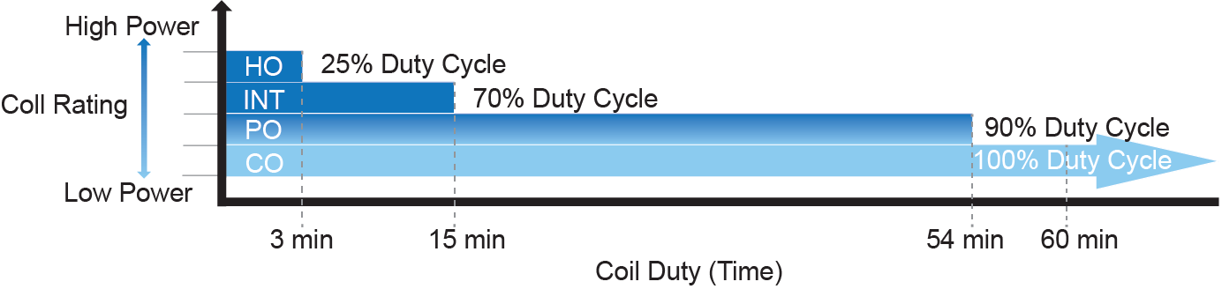

Frequency of Switching: |  | No. of Cycles: |  | per Seconds / Minutes / Hours / Days
Duty Cycle: |  |  | On Time in Seconds / Minutes / Hours / Days
 |  |  | Off Time in Seconds / Minutes / Hours / Days

Environmental Considerations
(e.g. humidity, moisture):

Albright International Ltd, Evingar Trading Estate, Ardglen Road, Whitchurch, Hampshire, RG28 7BB, UK,
Tel: +44 (0)1256 893060, Fax: +44 (0)1256 893562, Dedicated Sales Tel: +44 (0)1256 890030, Fax: +44 (0)1256 890043,
E-mail: sales@albrightinternational.com or technical@albrightinternational.com Web Site: www.albrightinternational.com

V1-06-20 Copyright © 2020 Albright International LTD

Application Form

ADDITIONAL FEATURES:

Feature: | Select as  Appropriate: | Suffix:
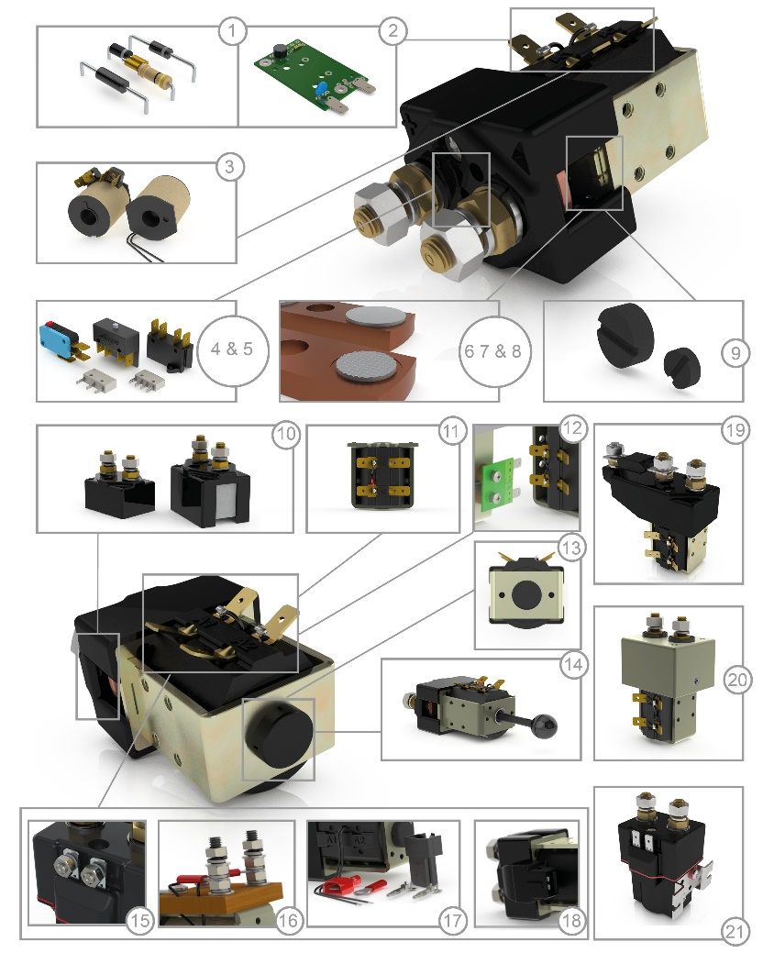
1. | Coil Suppression  (If required, specify type in Notes) |  | -
2. | AC Rectifier Board |  | -
3. | Vacuum Impregnation |  | -
4. | Auxiliary Contacts - V3 or V4 |  | C
5. | Auxiliary Contacts |  | A
6. | Large Contact Tips |  | L
7. | Textured Contact Tips |  | T
8. | Silver Plating |  | -
9. | Magnetic Blowouts |  | B
10. | Enclosed Contact  Housing / Dust Shields |  | -
11. | Magnetic Latching |  | M
12. | 6.3mm Spade Terminals |  | -
13. | Armature Cap |  | -
14. | Manual Override Operation |  | -
15. | M4 Stud Terminals  (Miniature Series & P Types) |  | -
16. | M5 Terminal Board |  | -
17. | Flying Leads  (If required, specify length) |  | F
18. | JPT Plug connection |  | -
19. | Fuseholder |  | -
20. | EE Type (Steel Shrouds) |  | EE
21. | IP66 Environmental Protected |  | P

If brackets are required, please select type: |  |  | 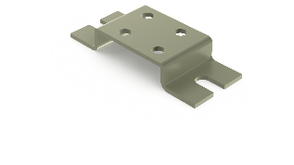 |  |  | 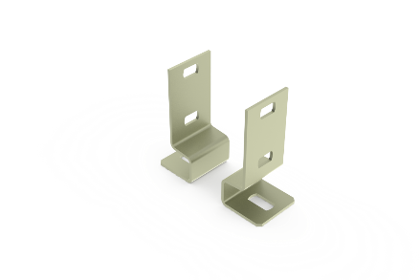 |  | 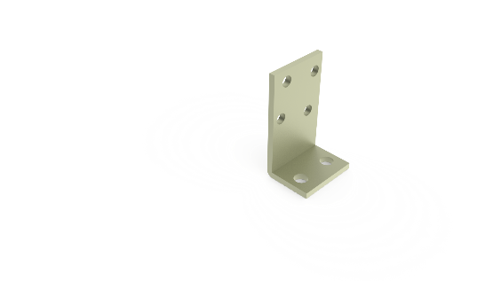 |  |  | 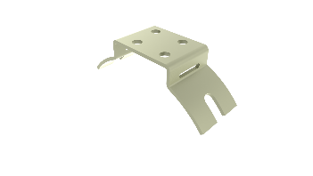
Further mounting options available via:
www.albrightinternational.com
 | Mounting Attitude: | Horizontal: |  |  | Vertical: |  |  |  | Other:

NOTES:

Albright International Ltd, Evingar Trading Estate, Ardglen Road, Whitchurch, Hampshire, RG28 7BB, UK,
Tel: +44 (0)1256 893060, Fax: +44 (0)1256 893562, Dedicated Sales Tel: +44 (0)1256 890030, Fax: +44 (0)1256 890043,
E-mail: sales@albrightinternational.com or technical@albrightinternational.com Web Site: www.albrightinternational.com

V1-06-20 Copyright © 2020 Albright International LTD

